Interactive Resume

Project Setup:
1. Navigate to - https://github.com/Ayeshaq09/Unified-mentor-projects You will see all 8 projects.
2. To get the projects onto your system: click on "Code" button and copy the link - https://github.com/Ayeshaq09/Unified-mentor-projects.git
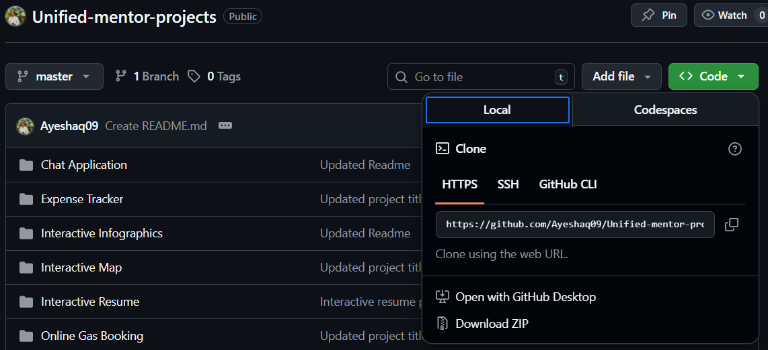
3. Open git bash and run the following command:
git clone https://github.com/Ayeshaq09/Unified-mentor-projects.git
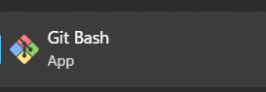
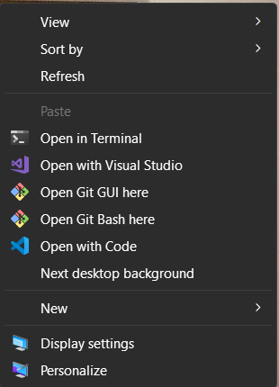
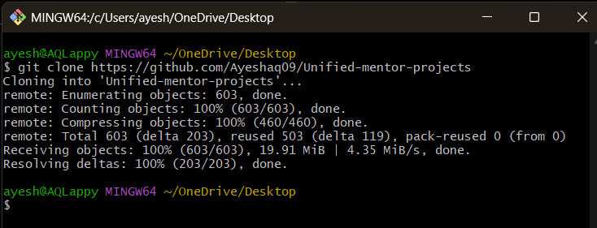
4. Once cloning is done, you get all the 8 projects onto your system.

About the project:
This project displays information such as my contact info, education details, work experience, skills and projects details.

Features:
This application contains:
1.Profile Page
2.Education Page
3.Work experience Page
4.Skills Page
5.Project Page with project list along with its github link
The app is mobile-responsive and is user-friendly.

Technologies Used:
- HTML5, CSS3, JavaScript, Reactjs
- react-tooltip for tooltips
- Boxicons for icons

Interactive Resume project setup:
- Open the folder in vscode and in terminal run – cd frontend
npm install

Then run - npm start

Functionality of the project:
The application displays my resume in book layout, each page contains information.
Use the Prev(<) and Next(>) buttons below to navigate through pages.

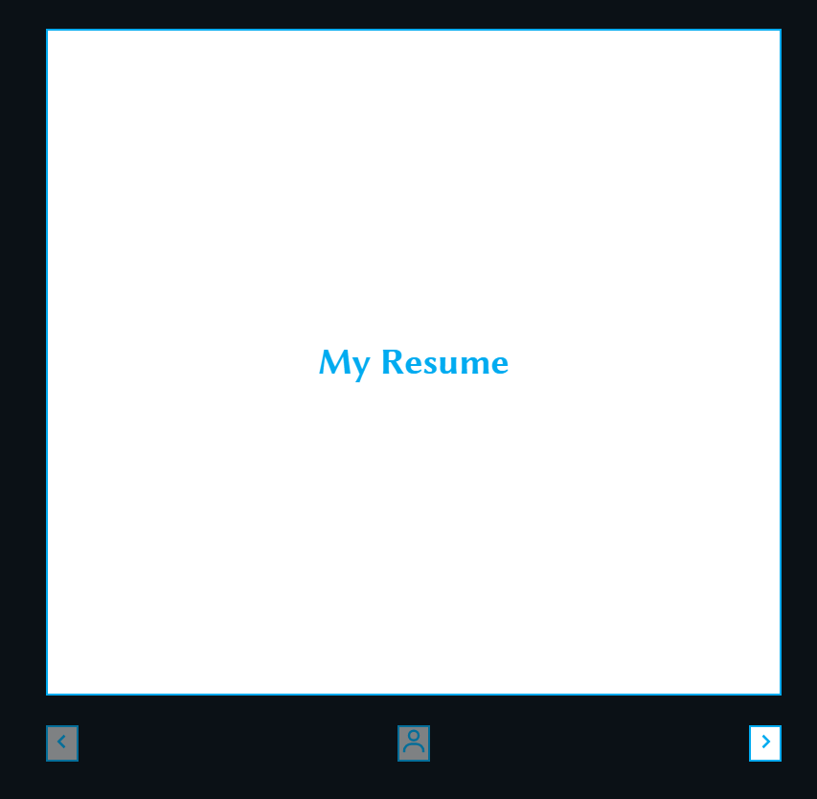

Pages:
1.Profile: The page displays my personal information and profile picture.
User can also contact me through my email, linkedIn and mobile number or click on "Contact Me".
User can download the cv/resume using “Download CV” button.
Hover over the contact icons on the page to reveal the tooltip.
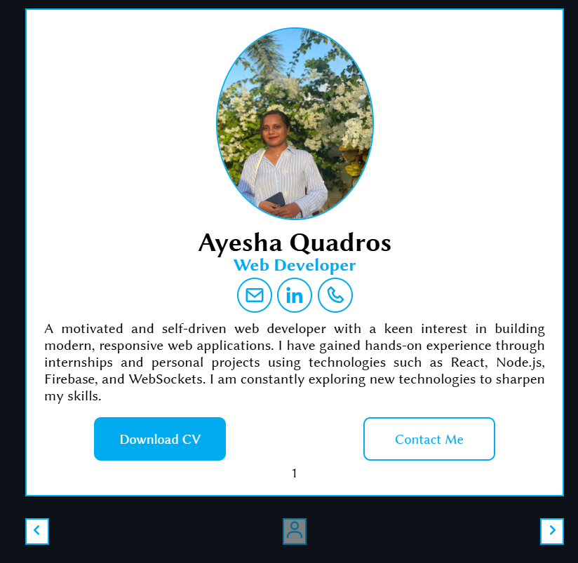

- Next page contains “Education” details.
Education: The page displays information for the class 10th, 12th and graduation.
It displays percentage, name of school/college, duration and some information for each.

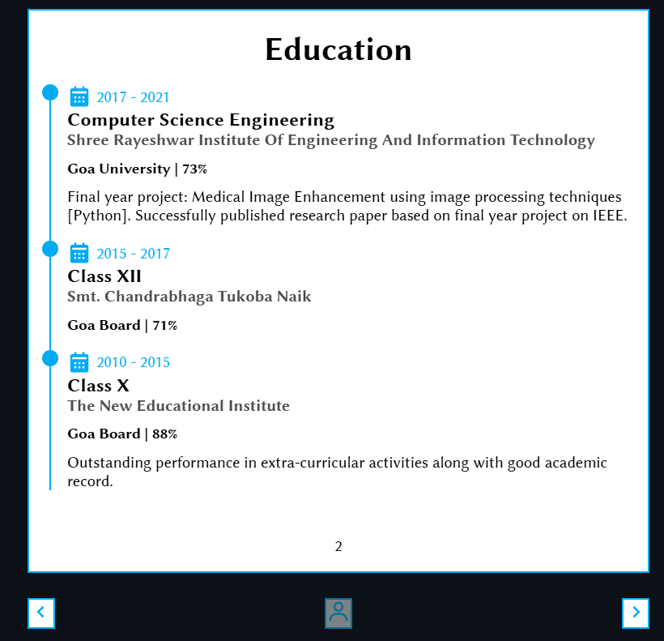

- Next page displays “Work Experience” details.
Work Experience: The page displays information regarding my work experience and internships.
It displays company name, duration, role and some work information for each.
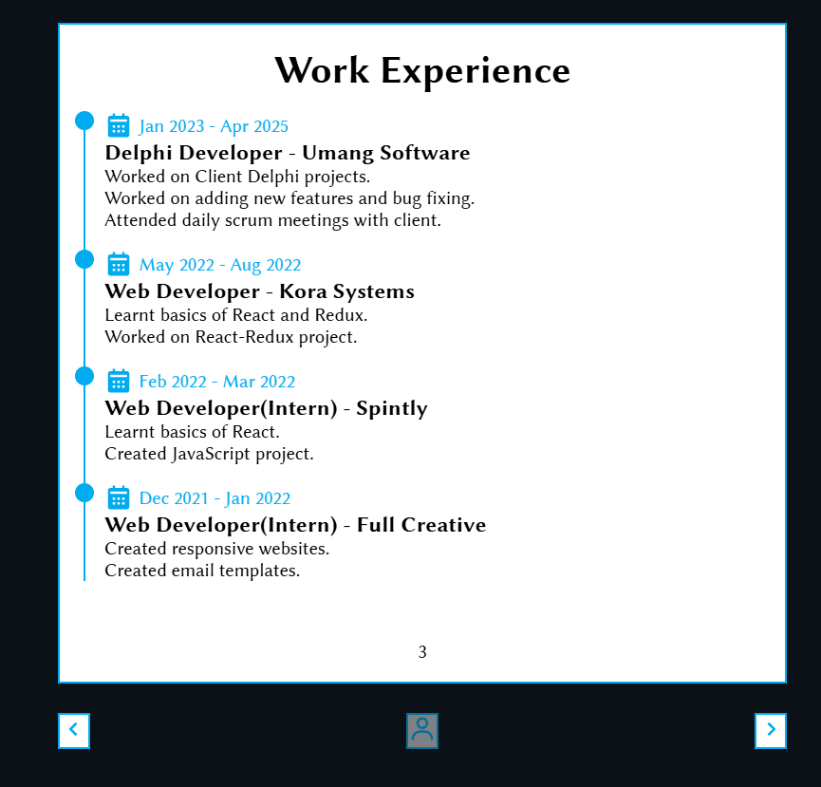

- Next page displays “Skills” details.
Skills: The page displays the skills that I have acquired through the work experience and internships.
Hover over skills for simple transition effect.
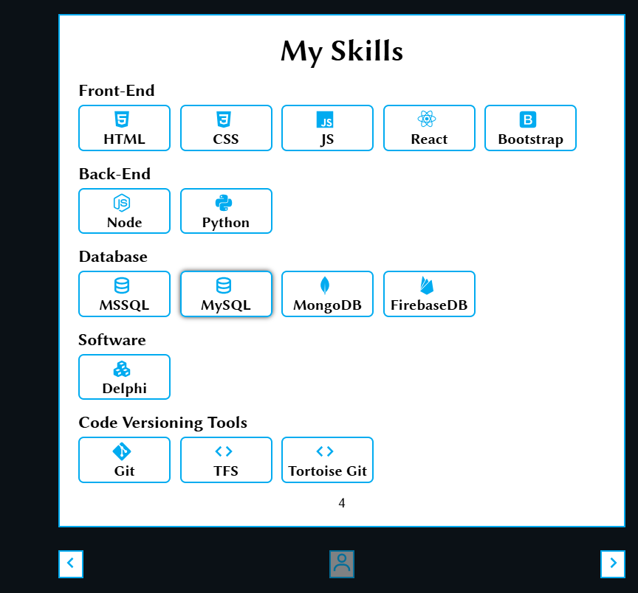

- Next page displays “Projects” details.
Projects: The page displays information for the personal react projects that I have worked on along with its github link.
Hover over the project name to show the tooltip for more details.
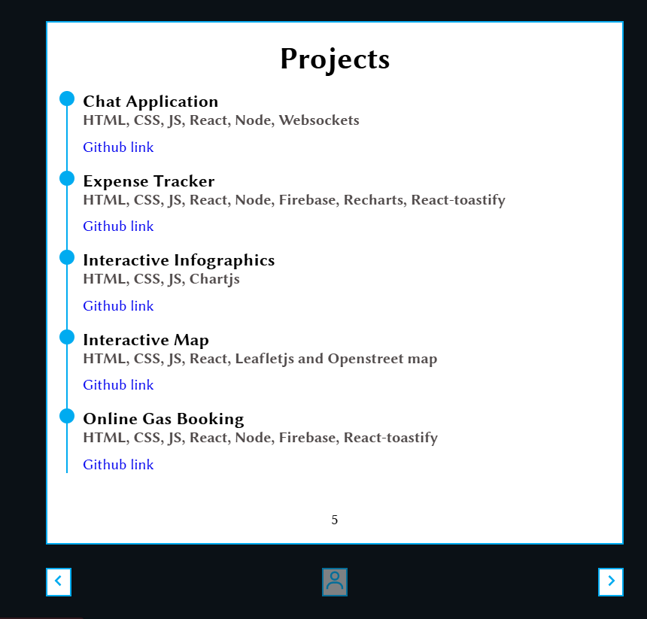

6.Profile button below activates when the user reaches the last page so to provide direct navigation to profile page.
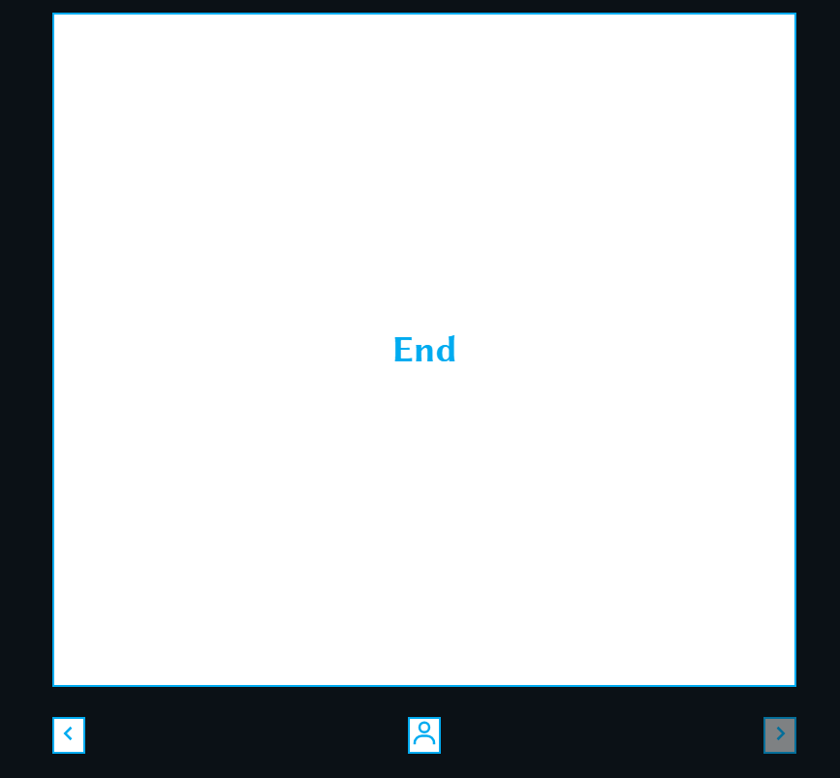

7.Resize the screen to check the responsiveness of the application.

